CMPEN 480: Computer Engineering Design
EE 400: Engineering Design Concepts
Fall 2016

Homework 7: System Level Design

Team ECE-602: Capacitive Touch Sensor
Nicholas Korzi, nwk5160@psu.edu
Xue Zheng Saw, xps5001@psu.edu
Luke Aaron, laa5250@psu.edu

System Level Design: Level 0

The Level 0 design for processing the sensor signal from the CPAP mask is given in Figure 1. Details of the inputs, outputs and functionality are given in Table 1.

Figure 1. Level 0 design for processing the sensor signal from the CPAP mask.

Module | CPAP Mask Contact Pressure Processor
Inputs | Tactical Data from CPAP mask in digital format (scaled from 0 to 2048).
Outputs | Pressure measurements in various units, graphs, alarm trigger.
Functionality | Convert and process contact pressure from the CPAP mask sensors to deliver different functionalities.
Table 1. Level 0 details for processing the sensor signal from the CPAP mask.

System Level Design: Level 1

The Level 1 design is given in Figure 2. Details of the inputs, outputs and functionality for each module in the design are given in Tables 2 through 3.

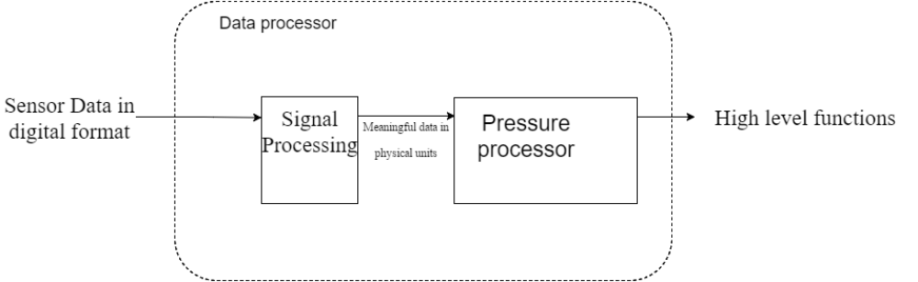
Figure 2. Level 1 design for processing the sensor signal from the CPAP mask.

Module | Signal Processor
Inputs | Capacitive sensor data from CPAP mask sampled and outputed in digital format.
Outputs | Clean, numerical data of pressure in physical units.
Functionality | Filters, process and calibrates the digital formated data into numerical data that is easy to understand and use.
Table 2. Level 1 Signal Processor details.

Module | Contact Pressure Processor
Inputs | Numerical data of pressure in physical units.
Outputs | Graphs, Detection of correct attachment of CPAP mask.
Functionality | Process numerical data into higher level functions.
Table 3. Level 1 Contact Pressure Processor details.

System Level Design: Level 2

The Level 2 design for the Signal Processor is given in Figure 3. Details of the inputs, outputs and functionality for each module in the design are given in Tables 4 through 5.

Figure 3. Level 2 design for Signal Processor.

Module | Filters
Inputs | Digital sensor data sampled at {X} hz.
Outputs | Digital data with noise reduced.
Functionality | Elimimate noise introduced by the sampling process and of the sensors.
Table 4. Level 2 Filters details.

Module | Physical Numeric Conversion
Inputs | Filtered digital data.
Outputs | Pressure data in numerical, physical units format.
Functionality | Process and calibrates the digital data into physical numerics.
Table 5. Level 2 Physical Numeric Conversion details.

The Level 2 design for Contact Pressure Processor is given in Figure 4. Details of the inputs, outputs and functionality for each module in the design are given in Tables 6 through 7.

Figure 4. Level 2 design for Contact Pressure Processor.

Module | CPAP Mask Correct Attachment Detector
Inputs | Data of contact pressure in physical units of measurement format.
Outputs | Indication of whether CPAP mask is correctly attached to face.
Functionality | Algorithm to detect if CPAP mask is attached correctly from the contact data measurements.
Table 6. Level 2 CPAP Mask Correct Attachment Detector details.

Module | Process to Graph
Inputs | Data of contact pressure in physical units of measurement format.
Outputs | Graph of contact pressure as time varies.
Functionality | Process the sampled pressure data and display as a graph in real-time.
Table 7. Level 2 Process to Graph details.

